1. Hwy 404 & Sheppard Ave East

(404 N Sheppard W Ramp Missing)

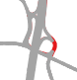

2. Pharmacy Ave & Farmcrest Rd + Pharmacy Ave & Terraview Blvd

(Missing Pharmacy Ave segment south of Farmcrest Rd

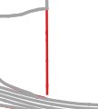

(Missing Pharmacy Ave segment north of Terraview Blvd

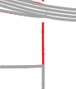

3. DVP & Lawrence Ave E

(Missing highway ramps south of Lawrence Ave E)

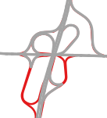

4. Don Mills Rd & Gateway Dr

(Missing Gateway Dr east of Don Mills Rd

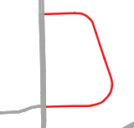

5. Don Mills Rd & DVP

(Missing DVP S Don Mills Rd S Ramp & DVP N Don Mills Rd N Ramp)



6. Morningside Ave & Sewell's Rd

(Missing Sewell's Rd east of Morningside Ave)

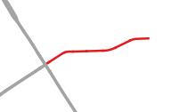

7. Gardiner Expressway & Lakeshore Ave E

(Missing expressway ramps at Lakeshore Ave E & Lower Simcoe St)

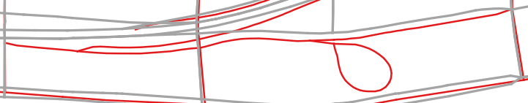

8. Strachan Ave & Lakeshore Ave W

(Missing ramps connecting Strachan Ave & Lakeshore Ave W)

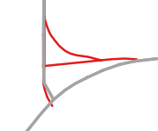

9. Jameson Ave & Lakeshore Ave E

(Missing Jameson Lakeshore E Ramp)

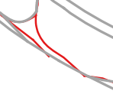

10. Jameson Ave & Gardiner W

(Missing Jameson Av Gardiner W Ramp)

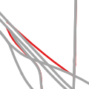

11. Sherway Gardens Rd & The West Mall

(Missing Sherway Gardens Rd and ramp connecting to Gardiner Expressway)

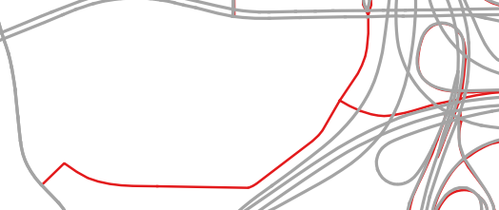

12. Hwy 27 & Belfield Rd

(Missing ramps at Hwy 27 & Belfield Rd)

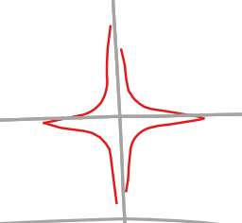

13. Gardiner Expressway & Park Lawn Rd

(Missing ramps connecting Gardiner Expressway to Park Lawn Rd)

